112103084
Arsh Maknojia
Assignment 2
1. Write a program to find sum of natural numbers using
a)For Loop
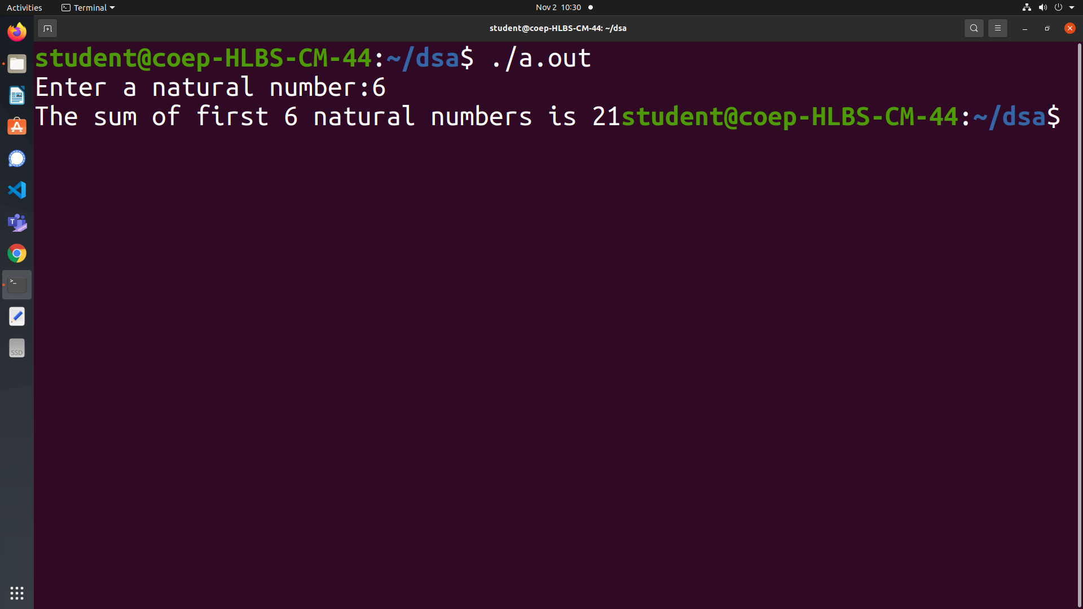
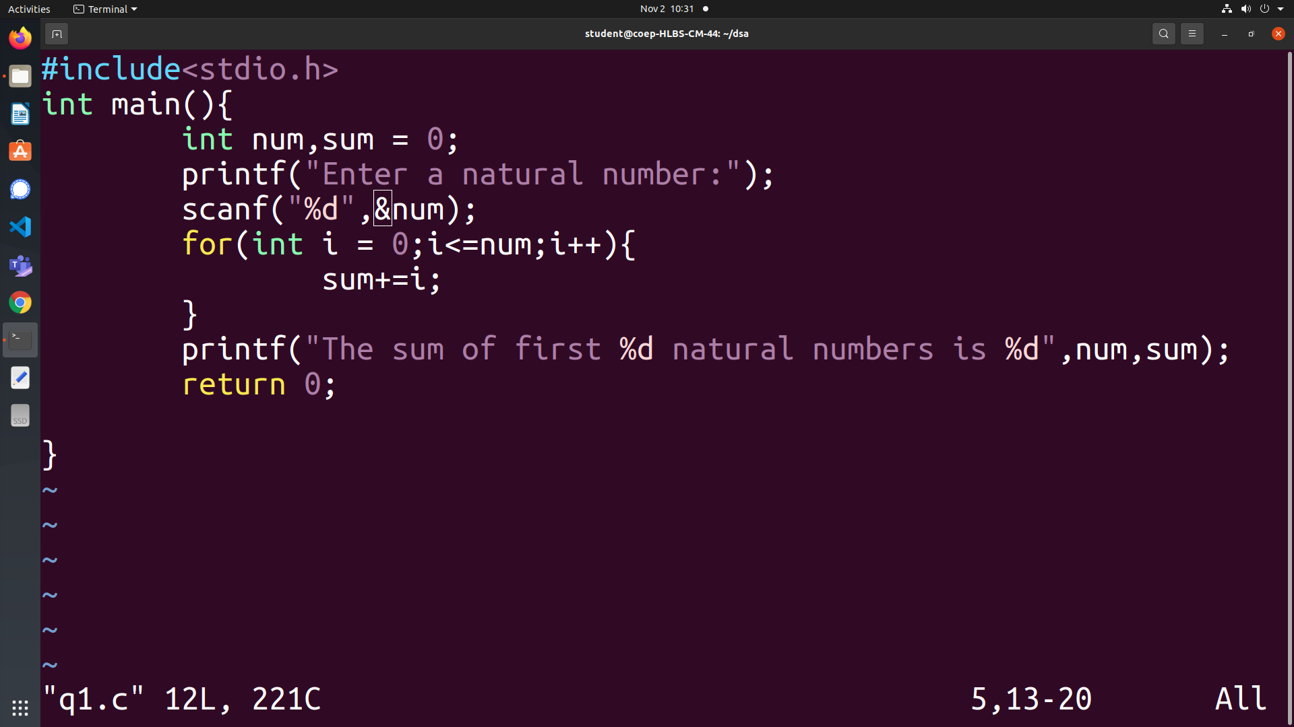

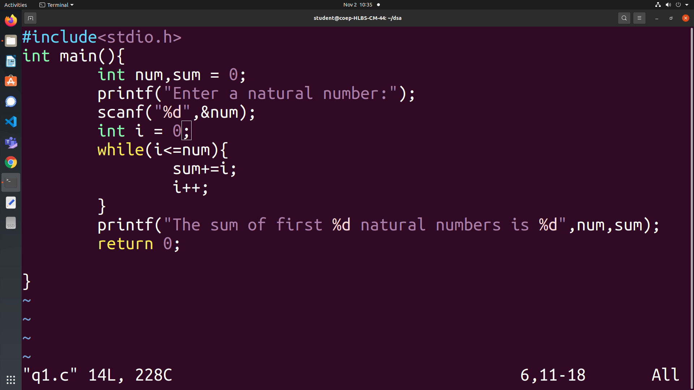
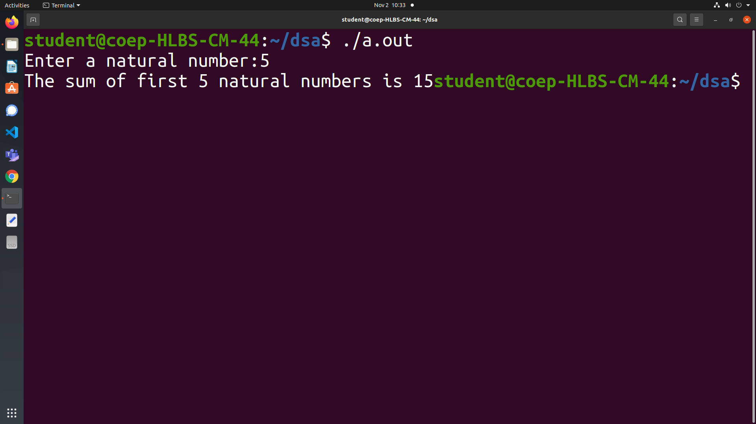
b)While loop

2. Write a C program to print the ASCII value of all alphabets (both lower and upper case) using
loop.
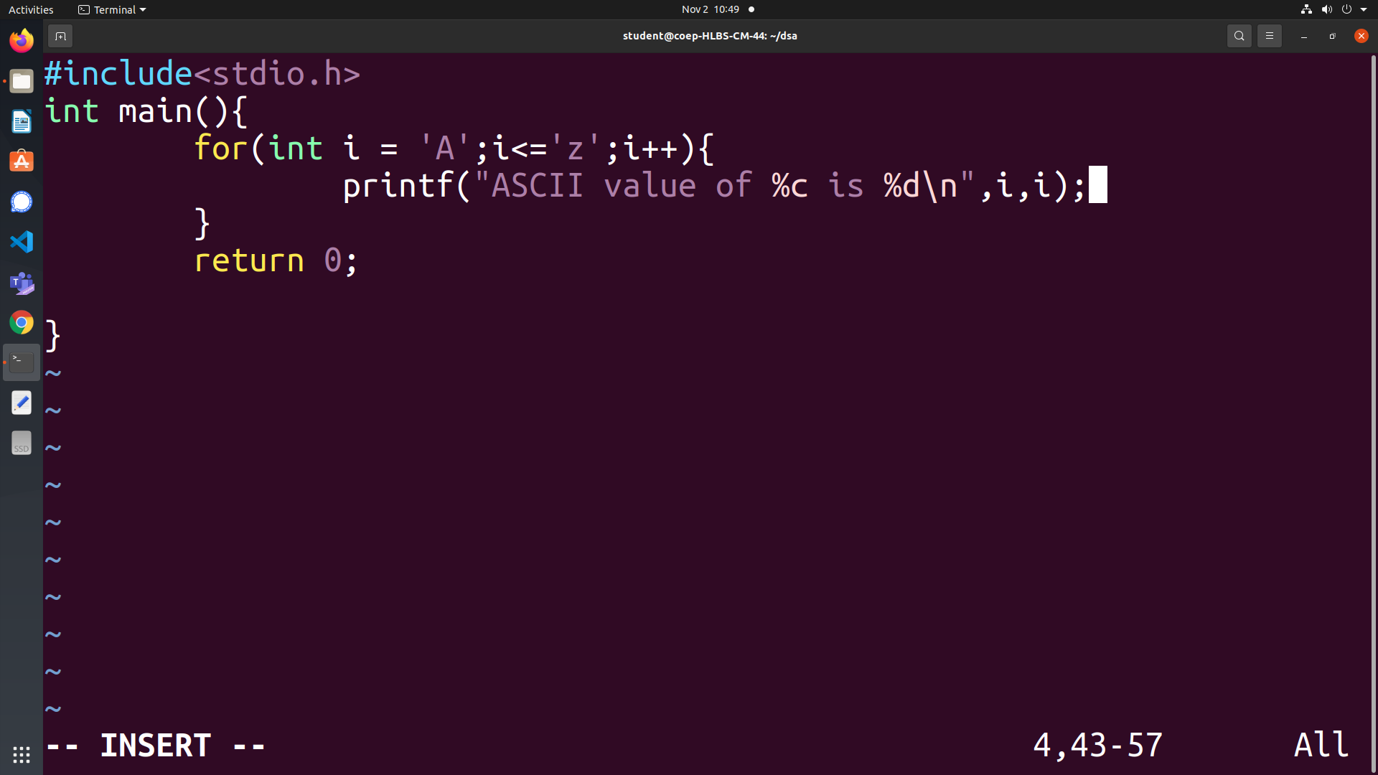
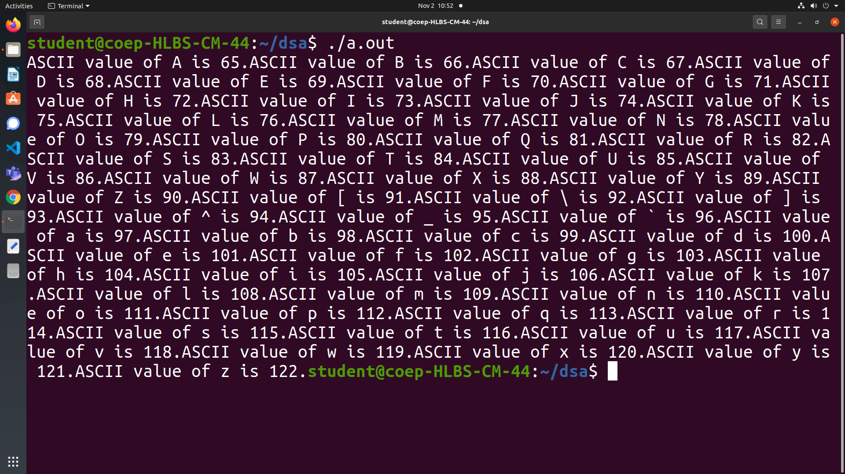
3. Write a C Program to find sum of digits at even location in a given number. Digits are
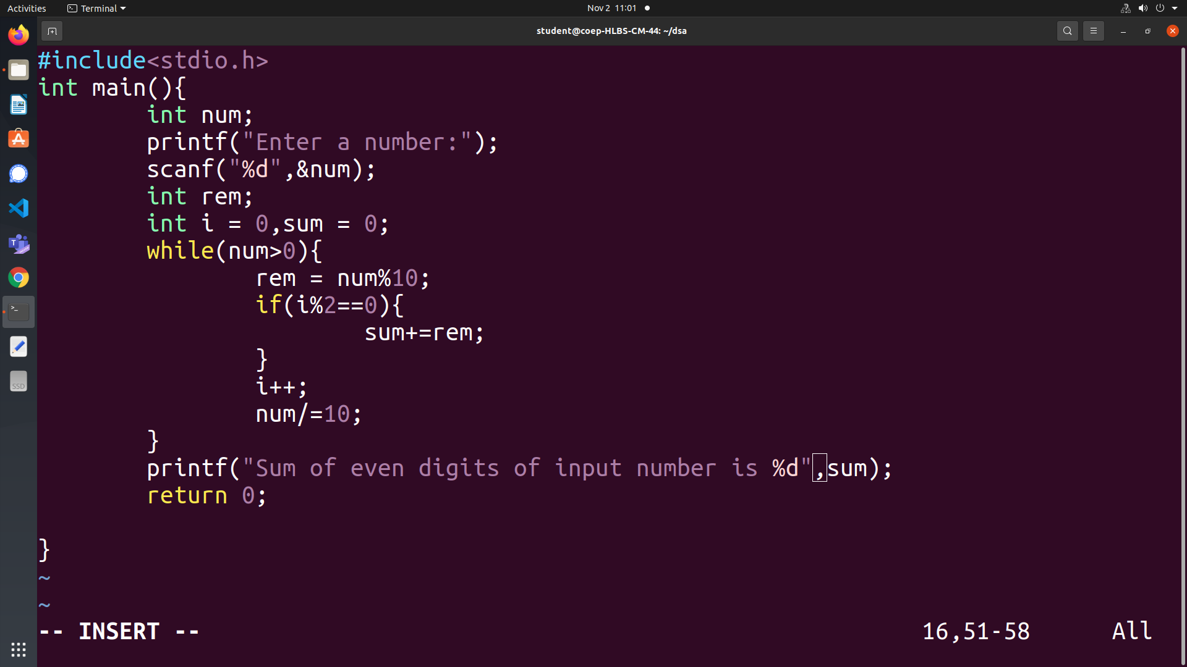
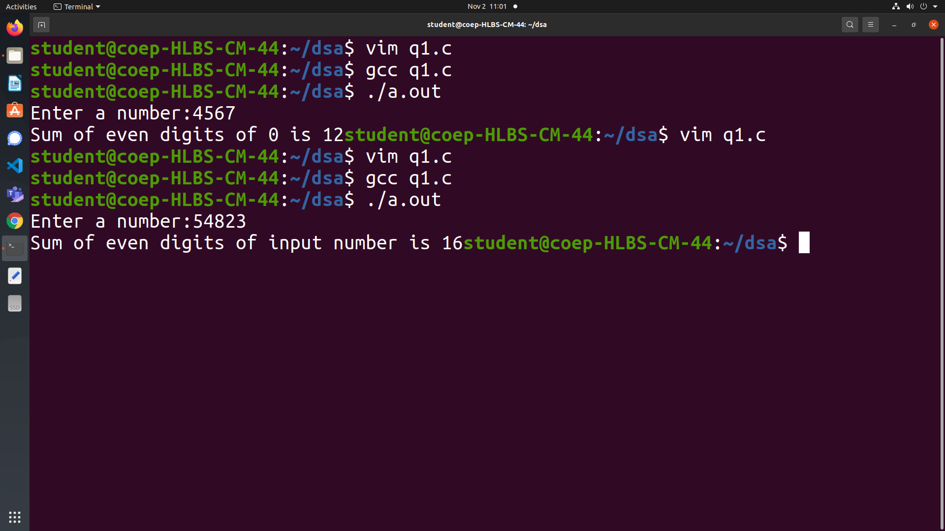
numbered from 0 to n-1 from right to left.
4. Write a C program to accept a decimal number (Base 10) and convert it to binary and count
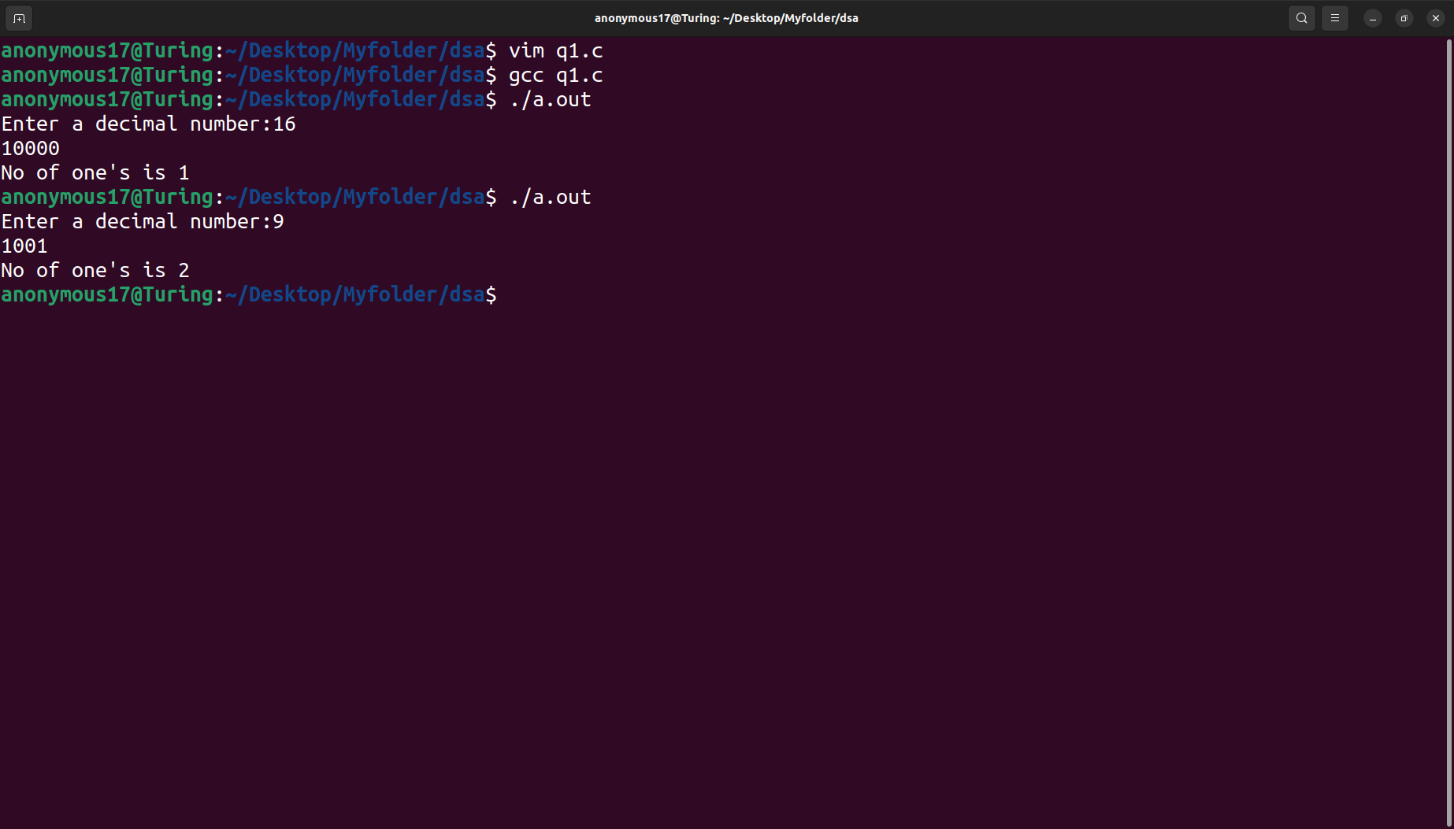
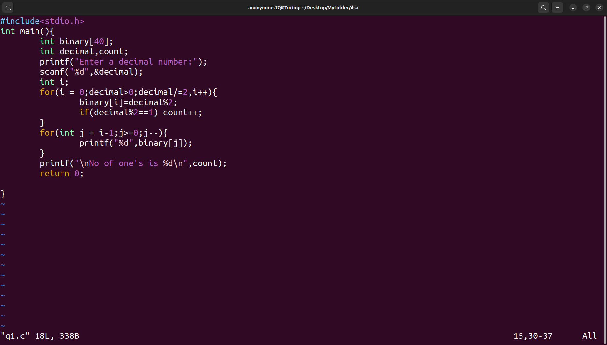
the number of 1's in the binary number.
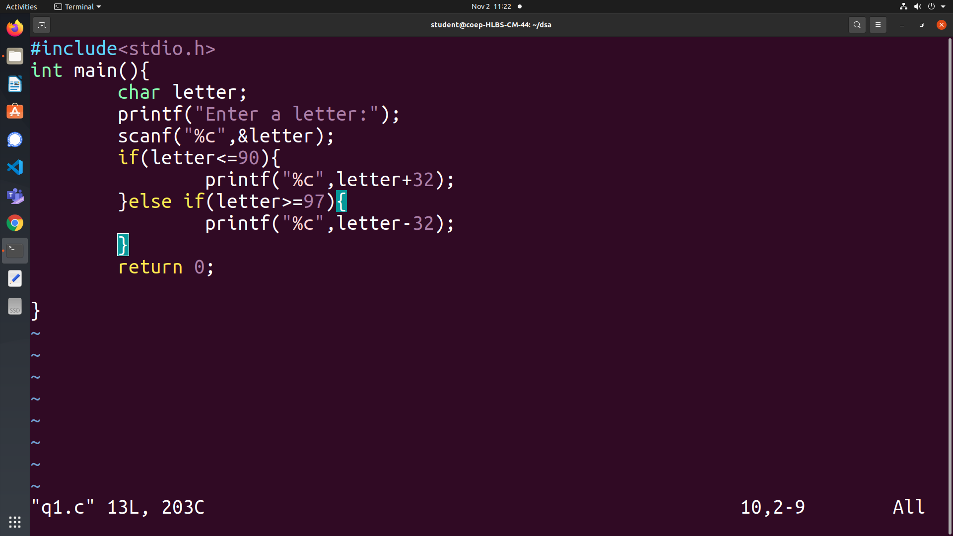
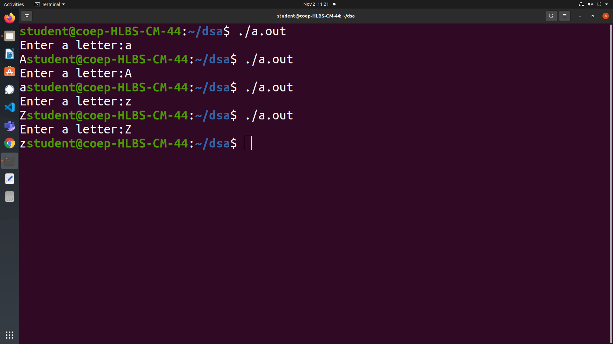
5. Write a C program to change the case of an alphabet.
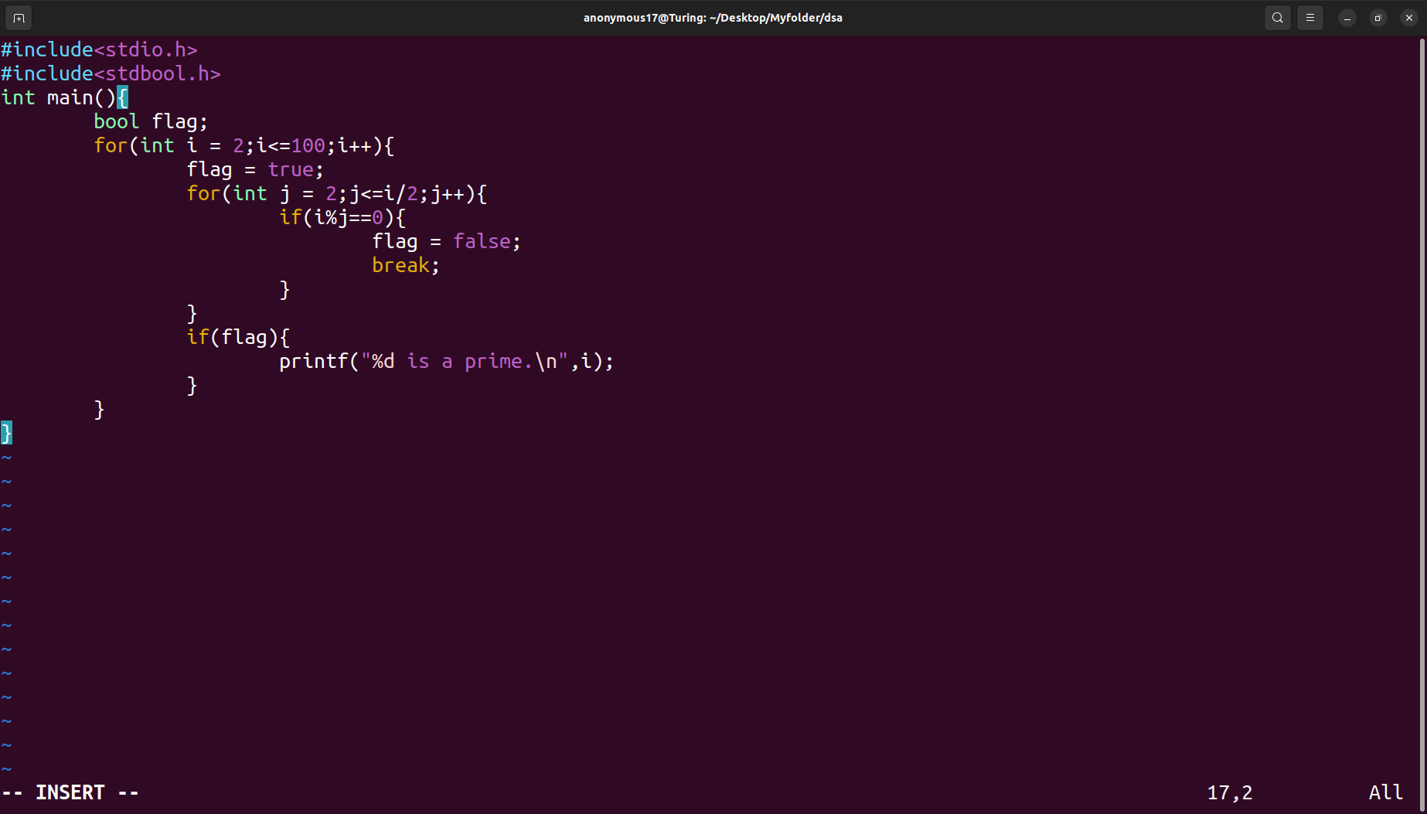
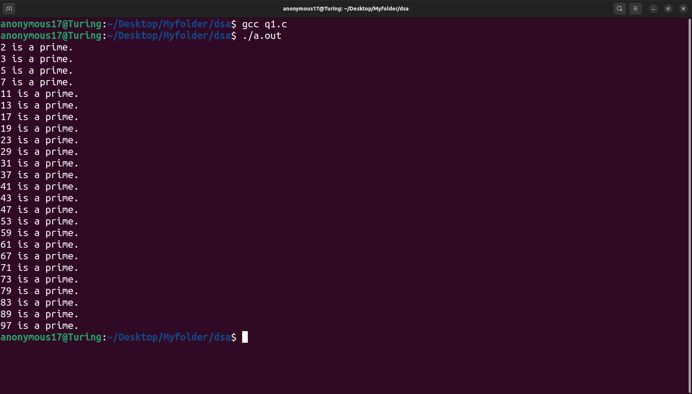
8. Write a C program to generate prime number series from 1 to 100.

